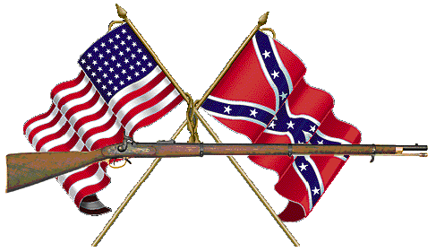
What was Metuchen like at the outbreak of the Civil War?

At the beginning of the civil war, Metuchen was still mostly comprised of farms worked on by long-established families: Campbell, Mundy, Ayers, Thornall, Compton, Hampton, Carman, Kelly, etc. An 1861 hand-drawn plan of the Metuchen area – done by Lloyd Grimstead in 1963 – shows the one railroad through town, the current Northeast Corridor, and only a few streets: Main, Middlesex, Grove, Amboy, Hillside, Durham, Woodbridge, and a very small Graham Avenue. All the houses and stores were clustered around these streets, surrounded by large undeveloped tracts apparently used for farm or wood lots.

Based on the 1860 federal census listings for residents in the "Metuchen PO" (remember Metuchen was not its own municipality until 1900), there were 1242 residents at the time. They are listed predominantly as farmers, but there were also a few carpenters and masons, school teachers, two doctors, some ship masters, ship carpenters, Sea Captains, shoemakers, wheelwrights, tailors, couple of railroad agents, clockmaker (Jason Hull). Nearly everyone was born in the United States, either New Jersey or New England, with very few from places such as Prussia, Bavaria, Ireland, Scotland, Saxony.

A list of residents born in Metuchen who fought in the Civil War includes Robert Bruce Crowell, a member of the board of education, and District Clerk for thirty-three years; C.C. Campbell; William Van Siclen; James Grimstead; Albert Acken, a grocer; David martin, a blacksmith; Oscar Lawrence; Colonel Houghten; Robert L. Mallory; and, James H. Oliver.

But many more later moved to and then died here: 44 Civil War Veterans are buried in the Presbyterian and Hillside Cemeteries – mostly in the Presbyterian cemetery. Reverend James G. Mason, also served before being “called” to Metuchen. Presbyeterian Church, Prohibition Ticket Candidate later on.

And then of course, there are those from what is now Edison, including General E.A. Carman. He was born in the Oak Tree section of Woodbridge Township and went to Oak Tree School. He is bBuried in Arlington National Cemetery (and is listed on their website). He may have been wounded in the Tidewater area of Virginia, and he fought at Gettysburg, and other places. Also, there was a Colonel Joseph Layfayette Moss, who became a Committeeman, and "Mayor" of Raritan Twp, and then Recorder of Metuchen.

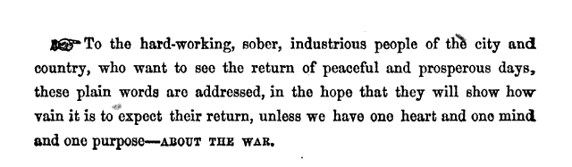
Another resident from Metuchen Veteran, Dr. Ezra Mundy Hunt, served as a surgeon during the war. Dr. Hunt was a noted physician and public health advocate whoe works continue to be cited today. In 1862 he wrote a treatise called “The War and Its Lessons,” and then he wrote "About the War: Plain Words to Plain People by a Plain Man" in 1863. Many remember him for his later "Metuchen and Her History" written in 1870. This second treatise – nearly anonymous – was about the causes of the War. His plain words were directed to:

In these treatises he avails upon the public to stay loyal to the Union and outlines the evils of slavery. Interestingly, Dr. Hunt was the grandson of Ezra Mundy. It was for Mr. Mundy that Thomas Peterson, who cast the first African American ballot under the auspices of the Fifteenth Amendment to the U.S. Constitution in 1870, served as an apprentice.

According to the 1860 Census, there were only six "colored" families listed in the village of Metuchen – the Cutter, Carmans, Randolphs, Stanburys, Divalls, and Dunn, and only 47 "colored" residents in all, 14 of which were living as servants or laborers in the more affluent homes: the Vandervere, Thornall, Hunt, Jones, Compton, Clarkson, Daniels, Thompson homes. The Clarksons were merchants who owned a general store. Theodore Hunt was a minister and father to Ezra Mundy Hunt, whom was just mentioned. The Thornalls were a very early landowning family who, along with the Mundys, were likely the first to build homes within the boundaries of current day Metuchen.

-Tyreen A. Reuter, November 2011

